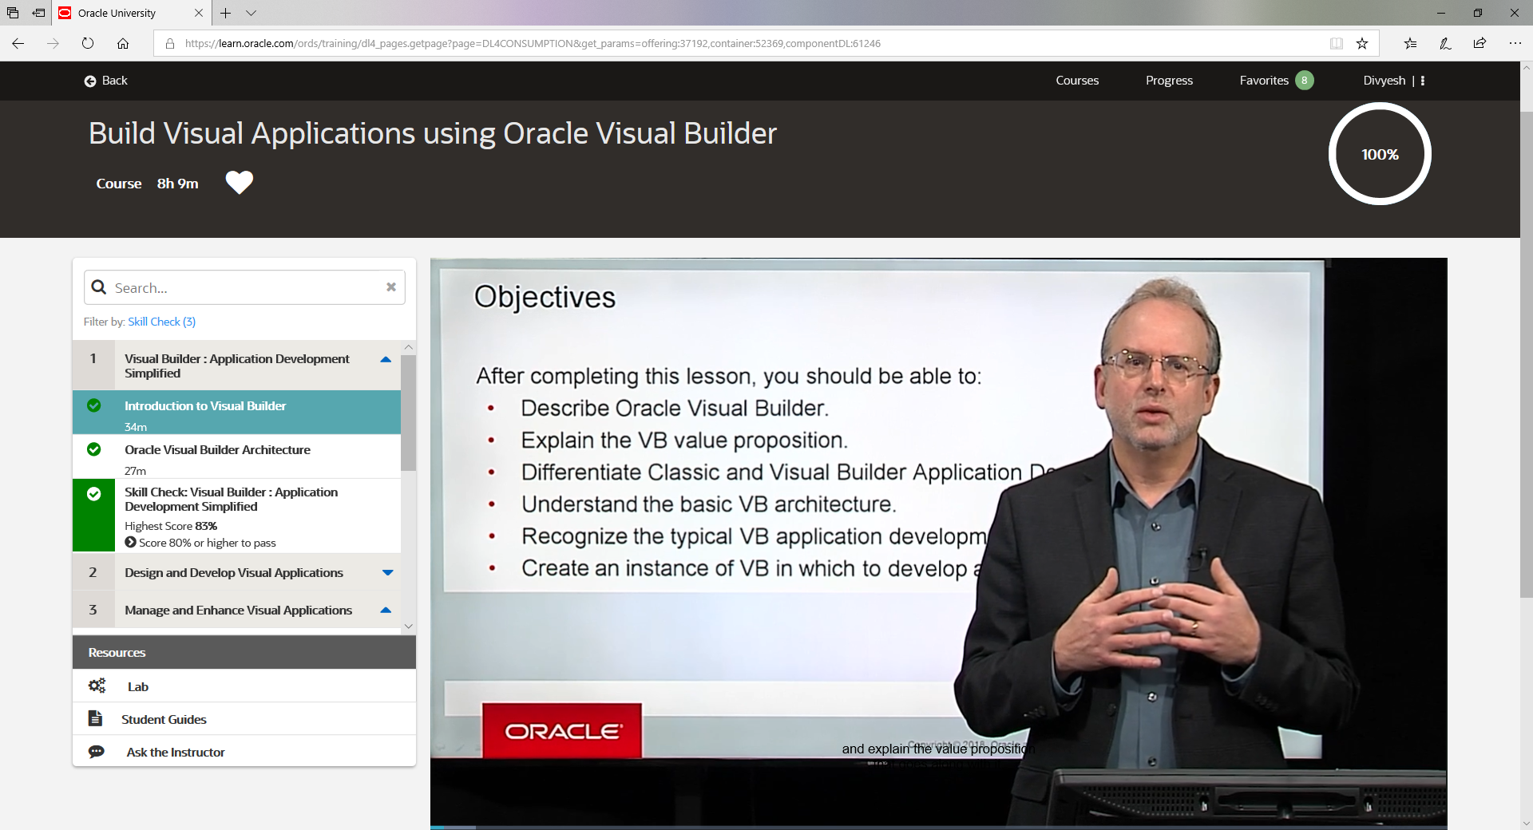

Welcome to the Build Visual Applications using Oracle Visual Builder course. My name is Jeff Picchione. And I'm a cloud delivery lead at Oracle University.

This is the first lesson of our course, which is an introduction to Visual Builder. So in this lesson, we're going to introduce you to the Visual Builder. And by the time you finish this lesson, you should be able to describe Oracle Visual Builder and explain the value proposition that goes along with it. What value does it bring to your organization to help facilitate your organization's outcomes?

We are going to differentiate between what we call classic Visual Builder and the regular Visual Builder application development. And we'll see there's two flavors, kind of an evolution there, which we'll explain. And you'll be able to understand that difference.

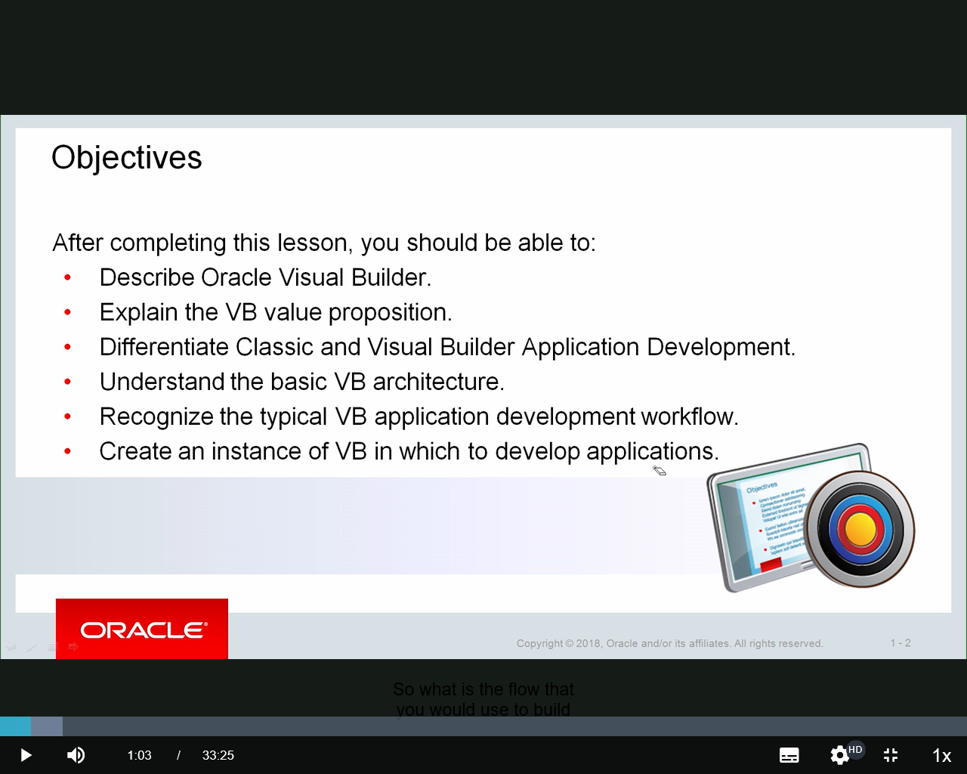We'll understand the basic architecture of Visual Builder.

What makes it click behind the scenes? And as we go through the course, we'll continue to look back into that architecture and understand those concepts. But just going to introduce it here at this point.

We'll recognize the typical application workflow.

So what is the flow that you would use to build an application in Visual Builder? And that's actually the structure we're going to use for the entire course. This module combined with the additional modules and lessons in the course will follow that workflow of building a Visual Builder app. And finally, we're going to wrap up this lesson with talking about having you create in the practices an instance of Visual Builder, which we're going to use throughout the course to develop our applications.

So this course assumes you have had no experience or maybe very limited experience with Visual Builder, maybe a little bit of development experience, a little bit of understanding of table structures at the database level, and tie those things together, because when we get into talking about Visual Builder, we're going to see how it's a tool that allows you to simply and effectively create very robust applications within a short period of time.

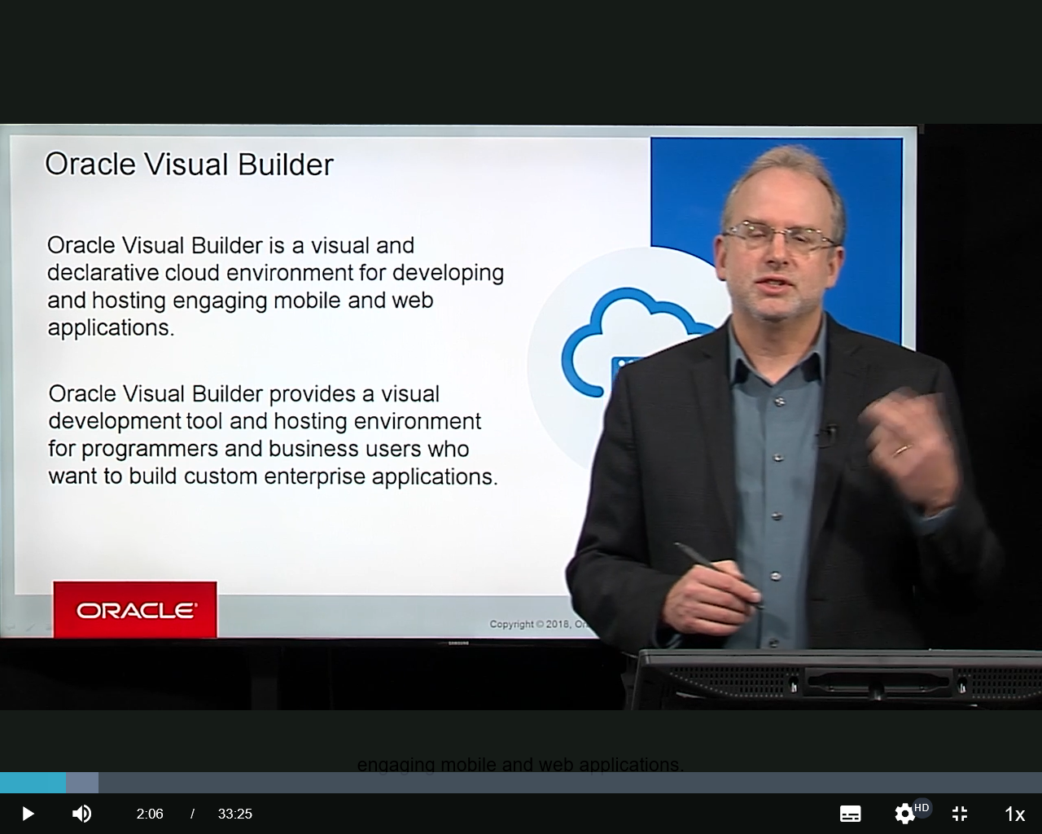So let's introduce Visual Builder here formally.

As it points out here, a couple keywords here, it's a **visual** and **declarative** cloud environment for developing and hosting engaging mobile and web applications. So there's a lot there in that statement.

First of all is this concept of being **visual**. So as we build applications, rather than getting right into text code, we do that visually. We drag and drop a lot. Or we set up properties by using these things called **Quick Starts**-- they're kind of like wizards-- to help us build the various elements of our application.

And another important word here is "**declarative**." Declarative as compared to imperative is that we are basically declaring what we want the finished application to look like. So we're basically saying, this is what we want the result to be. And then in the background, the Visual Builder builds the code that we're ultimately going to use or that's ultimately used for the application.

So it's not code-less. There's code. But we don't necessarily have to write the code. But one of the advantages we're going to see is what we point out here, what we're going to continue to see is that we can-- once we set that declaration, that declarative type approach of here is what the outcome is going to look like, we can always go into the code and look at the code that's constructed.

So it's really the best of both worlds. For someone who has robust development experience can build an application declaratively, drag and drop with that visual approach, and then actually go in and work with the code. Or for people who don't have a lot of code experience, they can still build applications and then have the flexibility, if they need it, to go into the code.

So the other things to point out here, it's these engaging mobile and web applications. Let's start with engaging,

**engaging** in the manner that it's contemporary. It's a look and feel that we would expect to see in a robust web application.

And very important point here. Can be deployed on a mobile device or directly through a browser over the web. So one of the things we'll see is when we get into creating our applications is focusing-- one of the first things we decide is, are we building **a mobile application or a web application**? And in both cases, those use the contemporary components, we call them, to make it a fully robust and engaging application.

As it continues to point out here, it's the development tool. And it's this **hosting environment** for programmers and business users who want to build custom applications. And again, the key here, it's **hosted in the cloud**. So you don't need any on-prem environment to work on this.

You're signing into your Oracle Cloud. And you're building an instance of Visual Builder. And from there, you're building these engaging mobile or web applications, all in the cloud through your development effort.

And then when it's done, it's hosted in the cloud. And we'll talk about how it can connect to different data sources and so forth as we work through this. But again, one of the key value propositions of any cloud service, Visual Builder ties right into that as having that capability of being hosted on the cloud.

Another thing to point out here, notice the **user community**. I mentioned this just briefly already. Programmers and business users. So as we talk through this, it could be a one-off kind of simplified citizen developer type effort is what some folks in the industry call it, which is the ability for someone who is not-- whose primary function is not to be a programmer, but their primary function is to carry out some business activity in whatever department they work in, but have some technical expertise, can come in and actually build some applications Pretty. Simply with Visual Builder.

And as we mentioned, we can extend that out to programmers. It's not just limited to those business users. Because the code is generated and because the code can be enhanced and modified for these Visual Builder applications, it's a very robust and useful tool for both programmers and business users. So hopefully that helps a little bit in understanding the big picture and some of the key elements we're going to see here.

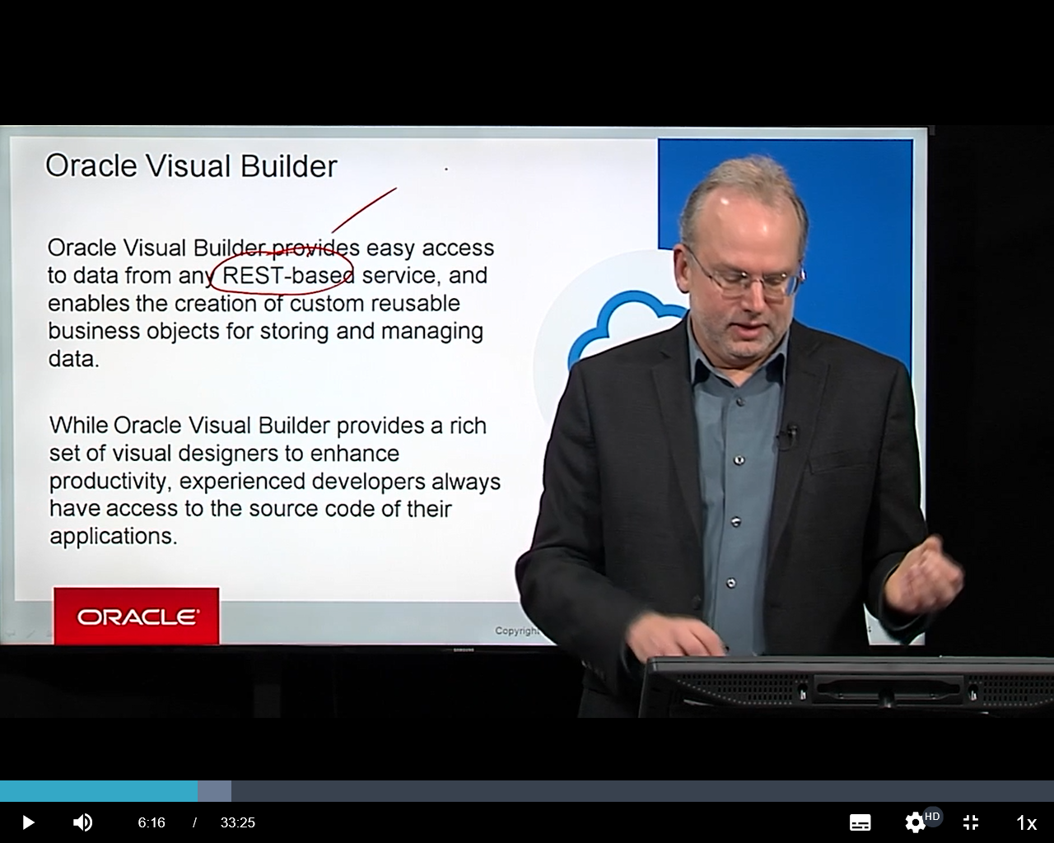Now, as we look into this a little bit more,

Visual Builder provides easy access to data with **REST-based services**. This is an important point. And if you're not familiar with REST, it's **Representational State Transfer**. And that's what it stands for. That doesn't really help describe what it is.

But the idea behind REST,

let's just kind of simplify it. It's how an application-- or in our case in Visual Builder, it's how the **Visual Builder application gets to its data source**. And the data source we're going to talk about can be constructed a couple different ways.

It can be custom by creating a **custom business object**. Or it can tie to an **Oracle SaaS application and extend that SaaS application** and the data that's used in there to be able to build applications around that. Or it can connect to any external what we call **service connection**. That service connection can be internal or external to your organization.

But all of those different connection methods tie back to this REST. And it's based on REST APIs, Application Program Interfaces. And in cloud environments today, in cloud platforms, the approach that is being used rather consistently in any effective cloud environment is to be able to have this capability to connect to data sources and to connect to various services using REST APIs.

And Visual Builder is no exception, very heavily leverages these REST APIs. And as we go through the additional modules, you'll see that, as you construct your applications, how these APIs are fully leveraged.

The other point that we make here in addition to the REST-based services to help manage our data is it has a rich set of visual designers. So different design tools that are in there we'll see to help either build our business objects if we're creating one of those custom business objects and to build our user interface, to build things like activity chains and look at the flow of an application and look at events and these different things we'll see as we work through Visual Builder, we're going to see these design tools that help you construct this. They have a similar look and feel to them, but they all do different things. And we'll kind of point what those different things out are as we work through the different modules.

So the two main points from this slide, data is accessed using REST APIs. And when we get into the tool, we have a set of these different design tools that are both consistent and specific to the purpose that they need to provide whether you're developing a web or mobile application.

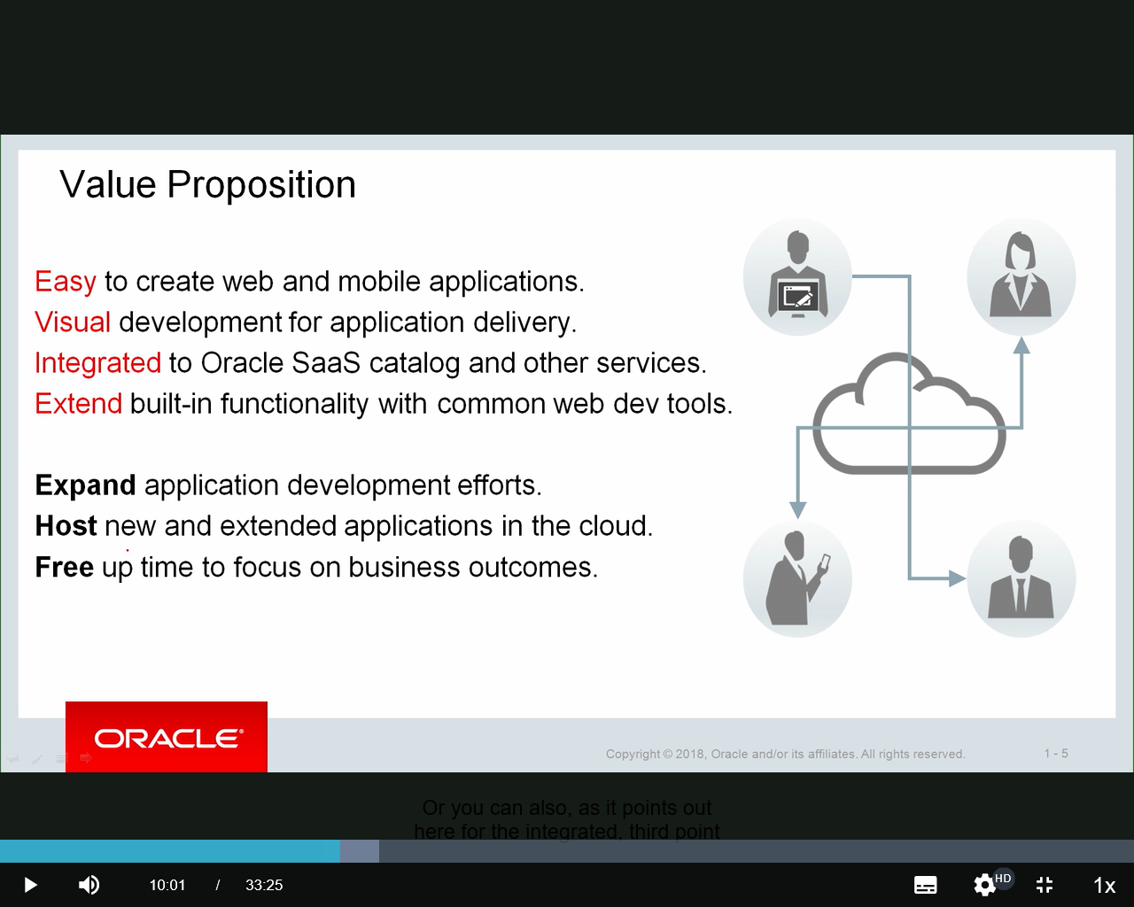So what's the value proposition?

What benefit does it bring to your organization to use Visual Builder?

And you see these highlighted words here.

It's **easy** to create web and mobile applications. You'll see that, especially when we get into the practices. It's dragging and dropping, connecting to a data source, maybe creating the data source, and having that capability in place to easily create an application, a fairly straightforward application.

It's **visual**. We talked about that as well. **It's drag and drop**. It's being able to, without having to get into a code editor and start typing in lines of code, or even a command line interface, it will do that for you behind the scenes.

So you can focus on what you want that whole outcome to be, that whole declarative approach. I want the page to look in this particular manner. I want the screen on a mobile application to look like this. You visually set that up and then bind those visual representations, those fields on a page, components to a back end data source to leverage that connection to the data. It's a very visual approach.

It's **integrated to Oracle SaaS catalog** and other services. So it's not just constructing custom business objects and just all the data is something that you define. You can do that. Or you can also, as it points out here for the integrated, third point here, is connect to Oracle SaaS catalog, and made reference to that.

But it's a really important point. This is a way you can extend your SaaS applications. So if you have a SaaS application let's say in the HCM area and you want to set up some additional functionality for it, you can build that additional functionality in Visual Builder. It'll have the same look and feel as your SaaS. It could even use the same data references as your SaaS by using the SaaS catalog to point to that set of, let's say, departments or employees or whatever it may be, and have this additional application. It does that, again, all through REST services.

And again, that integration also ties out to other REST APIs, with various types of service connections. Some external sources or other applications you may be running that expose those services as REST APIs can also be accessed. So we've got easy, visual, and integrated.

And the last point here is extend built-in functionality with the common web development tools. So take those current applications that might be in Oracle SaaS or somewhere else and extend those through Visual Builder. And it doesn't just have to necessarily be other cloud applications. If you have an on-premises application that exposes its services as REST APIs, those can be exposed to Visual Builder.

So maybe that's E-Business Suite. Maybe it's PeopleSoft. Maybe it's JD Edwards. Other applications that are on-premises applications, we can build visual applications to extend even those.

So it expands, helps expand your application development efforts. You can host new and extended applications in the cloud. And this last point, free up time to focus on business outcomes. So if you're spending less time developing, whether it's your business users or your developers, then you can focus on those business outcomes. Build the applications. Get the rudiments in place that you need to be able to construct this application so your organization can focus on ultimately the value that that application in conjunction with your other IT services brings to the business.

OK. So it's powerful. It's easy. It's visual.

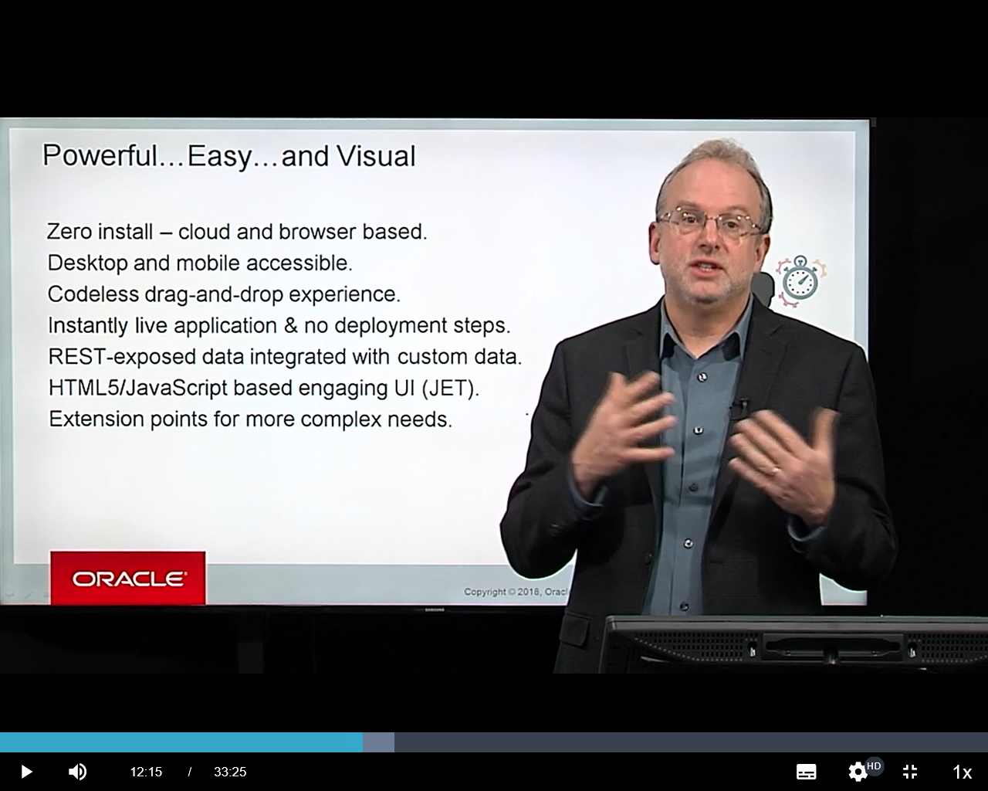And that's what we're trying to extend here-- explain here. As we see, it's powerful through drag and drop. It's easy through drag and drop. And it's a visual approach.

So if you look at some of the key points here, the whole point of being cloud- and browser-based.

So **you don't have to have that specific installation** locally to build this thing.

You can access the finished result either from a desktop browser or through a mobile device, including tablets. Any form factor, if you're talking a small mobile device, if you're talking a mini tablet, a tablet, full desktop application, whatever the case is, you can access through these various tools.

The experience is **codeless**. It's drag and drop, I've mentioned a couple times. And it can be 100% codeless if you want it to be.

Now, that doesn't mean there's no code. Code is created. That's how the applications are ultimately presented through these devices.

And with the visual applications that we're going to see, you can go in and make changes to the code, enhance the code. Let it construct the code for you initially. And then make whatever enhancements you need to do to it above and beyond that.

So it's a drag and drop experience. And if you're not familiar with code, you don't need to be. If you are familiar with code and you want to work with the code, you have that ability. So it's really the best of both worlds.

As it points out here, instantly live application. **No deployment steps**. We're going to take you through the lifecycle in one of the later modules, where we ultimately-- we **developed** the application. We then **stage** the application. And then ultimately, we go **live** with the application. And we'll show you it's a very simple process technically that you can incorporate into your release and deployment strategy.

The next point, we talked about the **REST-exposed** data on a previous slide.

And it leverages **HTML5, JavaScript, CSS-- Cascading Style Sheets**-- with an engaging user interface. And as the back end, uses Oracle's JET. We're going Io talk about the architecture here in just a little bit.

**JET is the JavaScript Extension Toolkit**, which is an on-premises tool that basically helped build applications with a visual approach and constructed the code in the back end. So that JET is being leveraged as part of the architecture of Visual Builder, which then ultimately creates the most contemporary approach of web development, which is HTML5, JavaScript, cascading style sheets extension, et cetera.

And speaking of extension, we also have extension points for more complex needs. So we'll talk about some of the **interface points**, interfacing to other Oracle Cloud Services, including the Process Cloud Service, very tightly integrated with the Integration Cloud Service. As we talked about, can extend HCM, ERP Cloud, HCM Cloud, CX Cloud, et cetera. Those other SaaS applications can be extended through service connections.

So it all ties back to **powerful, easy, and visual, fully integrated, flexible**. It's really a great balance between easy to use, simple to set things up, clear to define, but also having significant flexibility, flexibility to go in and add events and change events and trigger events different ways visually, and then even extending that one step further, which is actually getting into the code and making changes, enhancements, additions, whatever you need to to the code. So it does a really, really nice job of balancing those challenges, which is always a balance in any IT service that's provided.

If it's easy to use, sometimes it's not very flexible. If it's really flexible, sometimes it's not easy to use. And Visual Builder does a really nice job of balancing those two things. So it's powerful, easy, and visual.

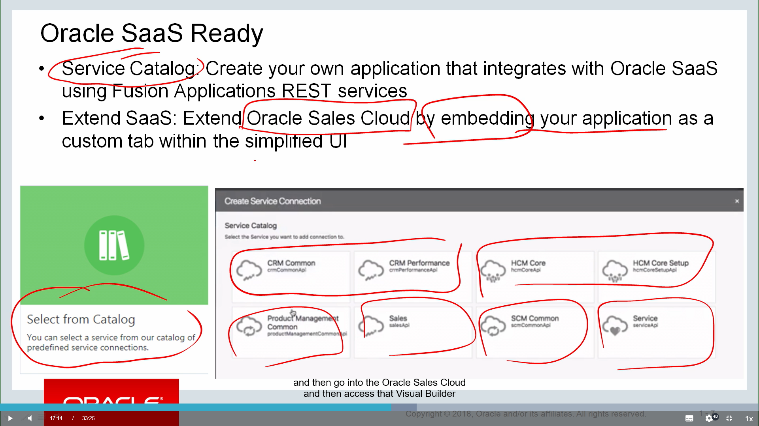So we made this point on a couple of the previous slides.

It's SaaS-ready through this thing called the Service Catalog. And basically, you can create your application. It integrates with Oracle SaaS. Extend those SaaS Fusion application REST services, so those, as we mentioned, HCM Cloud, ERP Cloud, etc.

And here's an example of one. We come into Visual Builder and we can say we want to create this thing called a service connection. And we select from a catalog. And depending on which SaaS applications you have in place, you can identify-- here's some around CRM. Here's a couple around HCM. Here's some around Product Management, Sales Cloud, Supply Chain Management, Service Cloud, et cetera.

So by drilling into those, you can see the different REST services that are exposed in those SaaS applications. And those SaaS applications talk to each other through REST APIs, so those REST APIs are already in place. And Visual Builder can then just leverage those and extend beyond those.

**Now, another approach to integrate with SaaS is we can actually embed a VB, a Visual Builder application into Oracle Sales Cloud**. So this embedding capability is there to be able to build a Visual Builder and then go into the Oracle Sales Cloud and then access that Visual Builder application almost as an embedded frame from within the Sales Cloud tool. So that embedding approach is something at some point we'll continue to see extend as well.

1. So either the first part of the service catalog, get the **SaaS data** on the back end.
2. The embedding approach, **create the Visual Builder application and with Oracle Sales Cloud actually expose it through the Sales Cloud with that simplified user interface.**

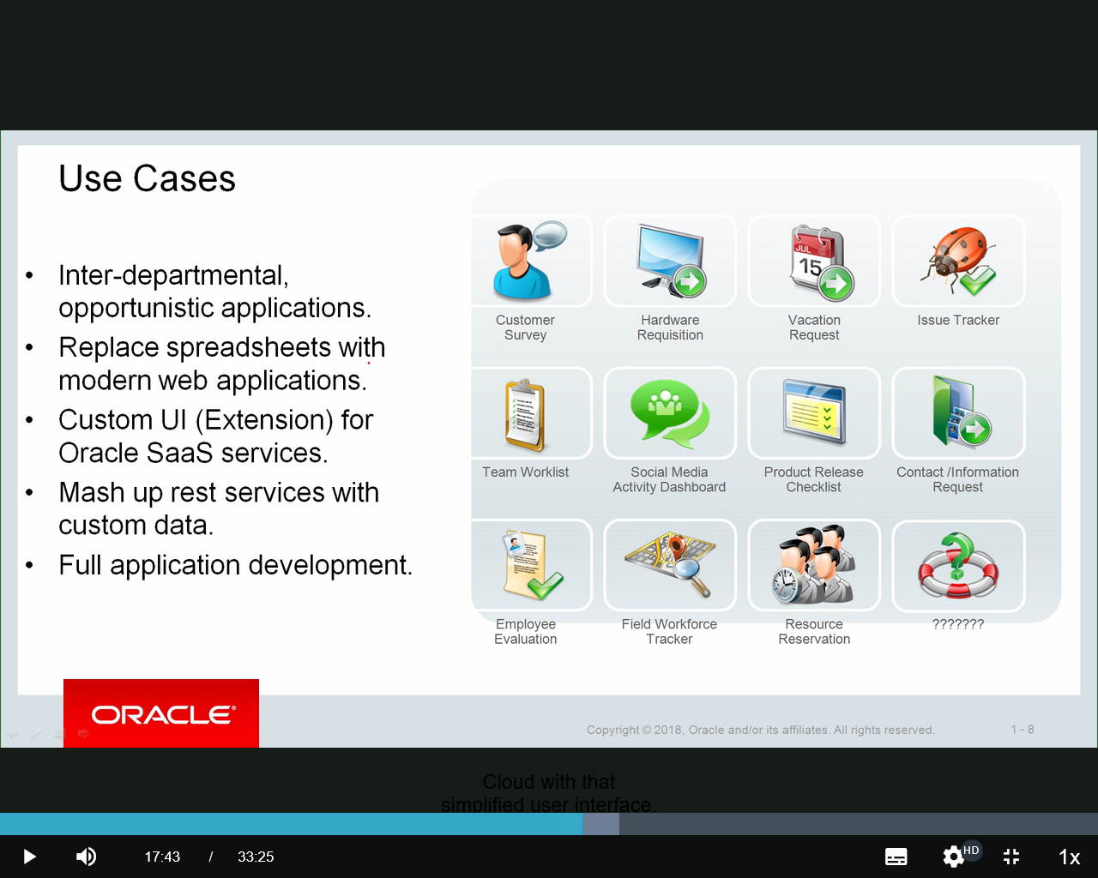

So here's a couple use cases for you to take a look at. And the point around these use cases, it's looking at kind of that citizen developer, that business user approach or audience that might be using the Visual Builder tool. And think that we have someone who is in a department. Let's say they're in the Accounts Receivable department, just picked that out of the air.

And within Accounts Receivable, there might be some technology requirements, maybe to do some additional tracking of some type. So we have people in that department who might have a little bit of comfort with either building applications or at least working with various tools to manage data and so forth, but are not professional developers. So what this slide is presenting is some possible use cases of how we could use Visual Builder in that type of environment.

1. So there might, as it points out here, be some interdepartmental opportunities to build some applications. Maybe within Accounts Receivable department, they might want to have a little application to share data with the order entry team or something. So they can leverage Visual Builder to build where they want to store the data, set up the security access for the different users, and build the front end to be able to do that.
2. This is a really good one here, the second point. **Replace spreadsheets**. So how many of those spreadsheets do you have floating around your organization to help run your business? And oh, is this the current version? And emailing them back and forth. Or maybe you're more advanced than that and have it stored in a shared drive somewhere. And even that gets old.
3. So taking that one step further, take what was typically managed through a spreadsheet and manage it through an application. Common application, here's the link. Here's the URL. Go out to the application.

Here's an interface you're familiar with. Setup your data. Modify your data. Change some statuses, whatever you need to do. So that's a really good use case in that scenario that we described, that kind of business user, citizen developer approach.

One of the things you'll see with spreadsheets also that Visual Builder does when we create data structures and business objects is we can actually import and create one of these business objects from a spreadsheet. So if we have a spreadsheet that has different columns of data, we can create a business object and then build an application off that. So a very relevant use case there is that replace spreadsheet point.

1. You can **build your custom user interface over SaaS services**, as we mentioned a few times. So we have that requirement to extend HCM. And we want to track some additional data.
2. **And then mash up REST services with custom data**. That's an important point. I think one of the previous slides here, back here where we talked about the sales catalog integrated to Oracle Sales catalog, for example-- Oracle SaaS catalog, excuse me. I use the word "or." You can build a custom object or connect to the SaaS catalog.

And really, that should be an "and." And that's what they're talking about here with this mash-up point is I can build a custom business object, track some data in that, and then connect to my SaaS catalog and pull in some data from that into my application as well. So you can truly do a mash-up.

**It doesn't just have to be your custom business objects or your SaaS catalog. You can combine those into various scenarios**. So again, we're building our own application, let's say within our department, but we need to leverage customer information from the ERP Cloud. We need to leverage payment term information from the ERP Cloud. Whatever the situation is, those can be leveraged and managed.

1. And **it's a full application development effort**. We go and we get into the workflow of this, of identifying our data sources, up through building the pages, up through wrapping up the development, staging for testing, and then ultimately deploying for use.

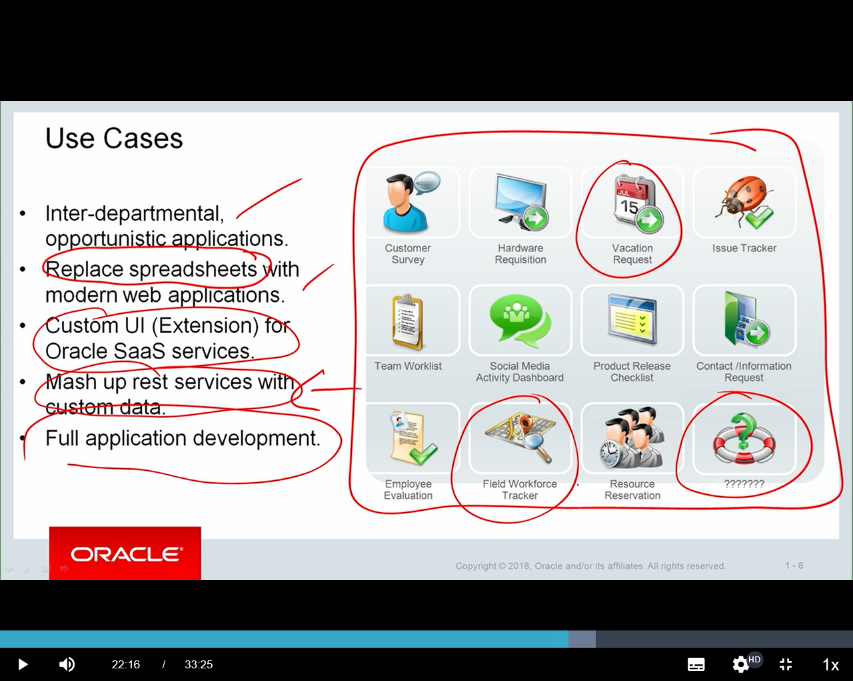

So there's some examples over here. I'm not going to walk through each of these. But you can see some example scenarios where some things, maybe vacation requests are handled through e-mails now and you want to update that. Or maybe you need to track some activity that's happening with your field workforce.

And then here's a good one. Whatever possibilities you can think of, whatever your business requires that might be currently managed in a spreadsheet, et cetera, can be extended.

Now the one thing I want to mention and that I started this whole discussion on this slide with is that this slide is talking about those business users. It's talking about those citizen developers, someone in a department who has another area of focus. I'm an accounts receivables expert, but I'm going to help build an application. That capability is there.

But keep in mind that this tool is just as effective for developers. It'll give a developer an ability to do any of these things above and beyond, to build an application and then be able to make it more robust and extend its capabilities beyond things that are delivered with Visual Builder, by either creating and accessing custom components, modifying the code in such a way to meet specific exceptions to regular business rules, and so forth.

So although this slide is focusing on kind of that one-off type interdepartmental opportunity or replacing spreadsheets, it's a lot more than that too. And that's where the developer piece comes in as well.

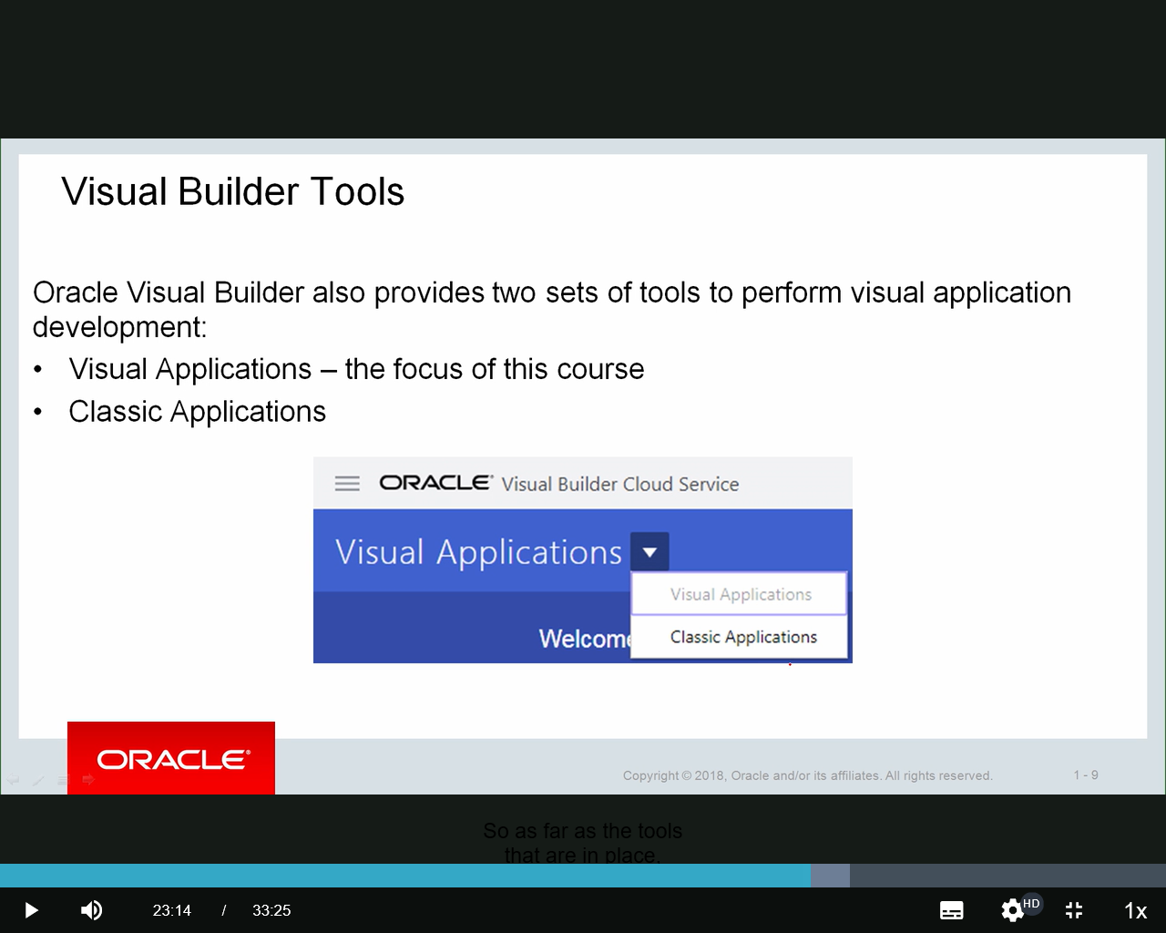So as far as the tools that are in place, so Visual Builder actually has two tools. And they're listed here, Visual Applications, which is the focus of this course, and Classic Applications. And we have another course in the Subscription that focuses on the Classic Applications.

Now, you'll see this here. As soon as you come to the Visual Builder home page, you have the option here-- it defaults to Visual Applications-- to go from Visual Applications over to Classic Applications.

Now I'll just give you a little background here. Historically with Visual Builder, it started with just the Classic Applications. And the Classic Applications did a lot of what we just talked about, the ability to drag and drop, build applications, a lot of those use cases we talked about on the previous slide.

And as the product evolved, it evolved into this ability to take those purely visually constructed applications and be able to do things like access the code and change the code and load in custom components and so forth. So the Visual Applications is what I've been describing up to this point. But historically, it's taken the best of what the Classic Applications could do and basically made it more flexible.

It's given it a different user interface, a different look and feel. But they can accomplish the same thing. So the Classic Applications are still available and are able to use. And again, if you're looking at developing in that, we have another course in Learning Subscription that focuses on that.

This course is going to focus on the Visual Applications. So keep that in mind, that that capability is there. So if you go into your instance and start working on it, and it looks really different than what you're seeing in the course here, double-check that you're actually working in Visual Applications and not just the Classic Applications.

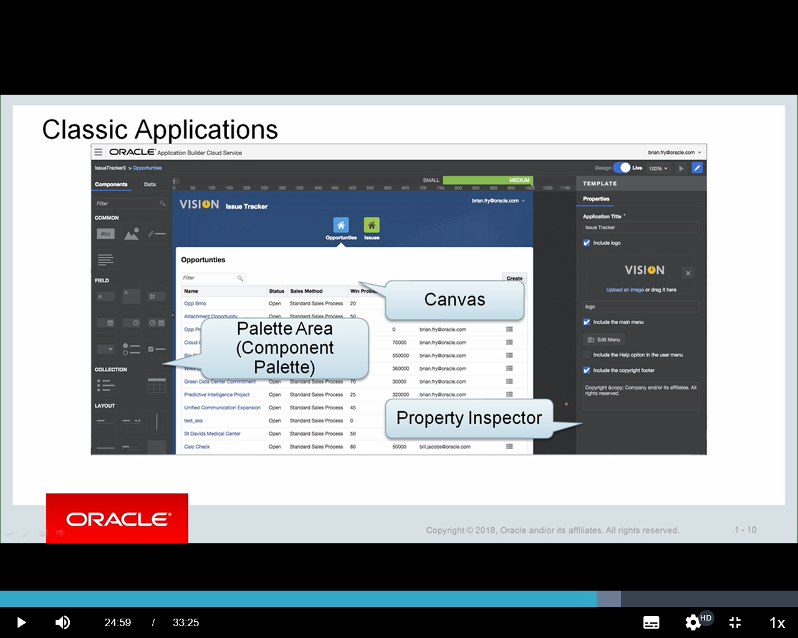So this is pretty much the extent we're going to talk about Classic Applications what I just talked about in this page. So it points out within Classic Applications, as soon as you come in, you're presented with that visual interface.

So what we see off to the **left is a palette area**. In this particular case, it's showing what we call a **Components palette**.

That terminology hasn't changed. A component is basically an element on a page. Maybe it's a different **type of field, a large field, a text field, a numeric field, et cetera, or a collection of data**.

And you're going to see that terminology is all the same with the Visual Applications. It's just a different way of constructing it.

So they have this palette area.

**They have a canvas, where we construct and build the application. There's different page tabs**.

And they have a **Property Inspector**. And the Property Inspector basically says, I'm looking at one of these things on the canvas. Tell me more information about whatever it is that I'm looking at.

Now, in the Classic-- that's the Classic Applications. Now, here's the Visual Application. And again, meeting that balance between easy to use and flexible. There's more here because it's more flexible.

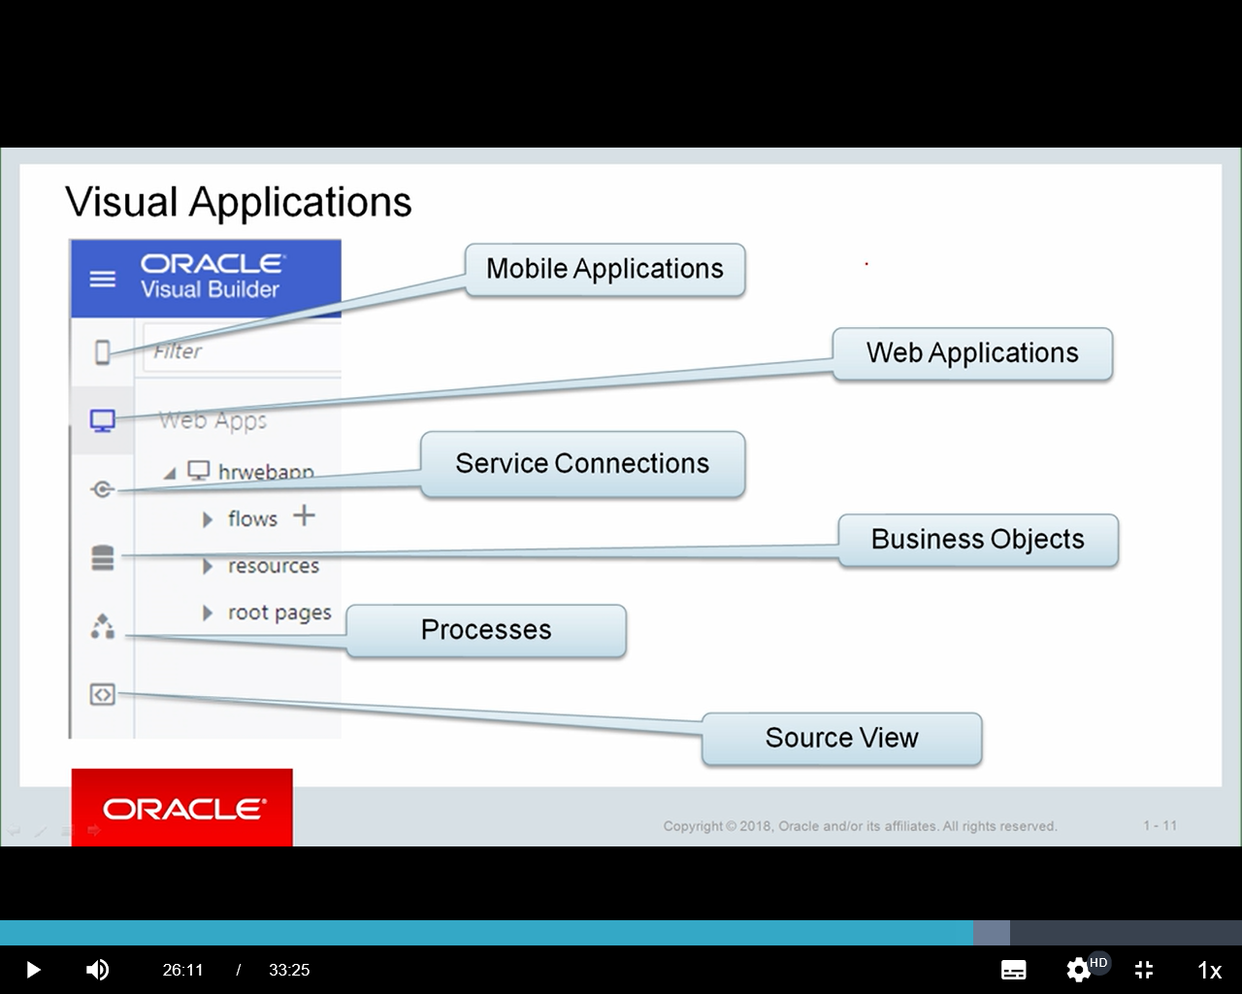

So when you come in to create a Visual Application, again, the focus of this course, you're going to see different things here.

So initially, you say, I want to build an application. And within that you can have a **mobile** set of applications and/or a set of **web** **applications**. And that's what the very first two icons display here.

And then notice, above and beyond that, we have **Service Connections**. Now in the-- well, actually, yeah, we have Service Connections, which is the ability to connect to our data sources. And one of those data sources may be a custom business object or **a business object that comes from another source**.

And just for comparison purposes, if I go back to the Classic Applications, in the Component palette, there's one tab here for Data, pretty much where you construct the business objects. And it does the service connection logic in the back end. Here, we can extend our use of the data we connect to with the Service Connection. So that's just one example.

Other things we see here is the ability to connect to the **Oracle Process Cloud**.

And this is one we've been talking about a lot, really want to emphasize here, but big difference between this and Classic is **the source view.** Being able to construct an application and go look at-- and not just look at it, but enhance and change and add to or remove or whatever you want to do within that source, but actually go into that source view of your applications as well.

So it's taken the Classic Applications and it's made it more flexible. And by making it more flexible, there's more capabilities for both the business users and the developers as they construct their applications.

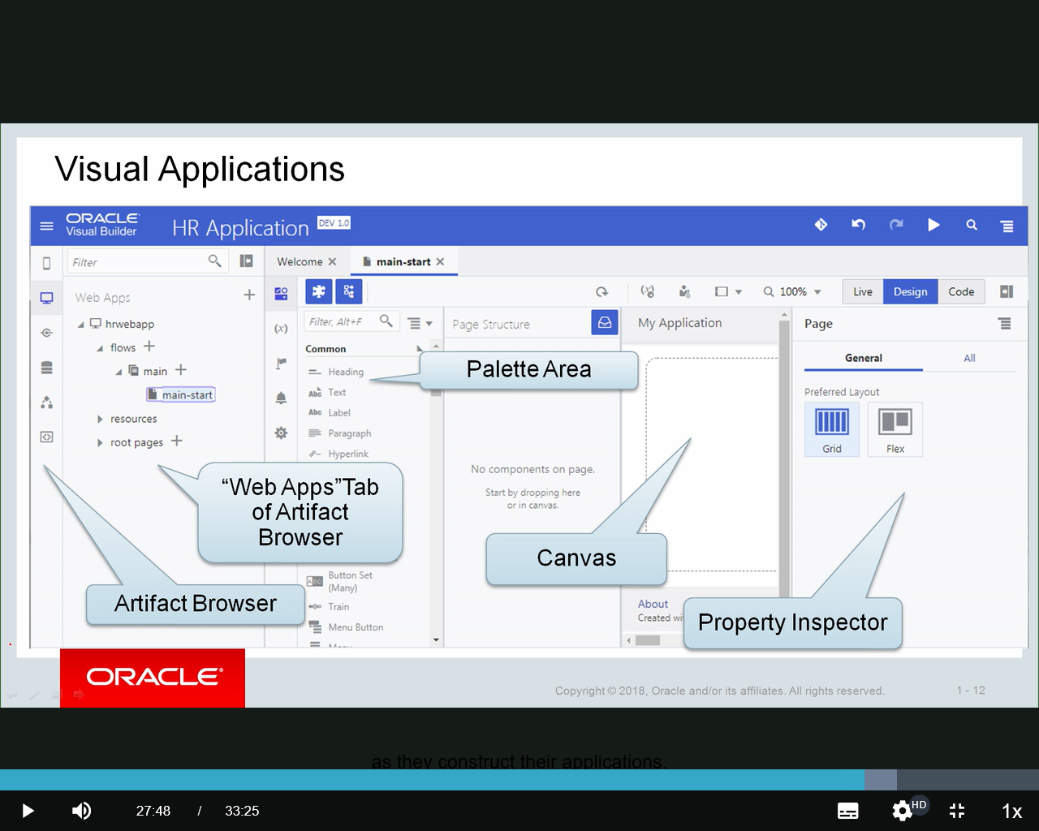Here's a little bit more on the Visual Application. In this case, we're looking at a web application. We'll get into the different editors and so forth here in other modules, but just kind of look at this flow.

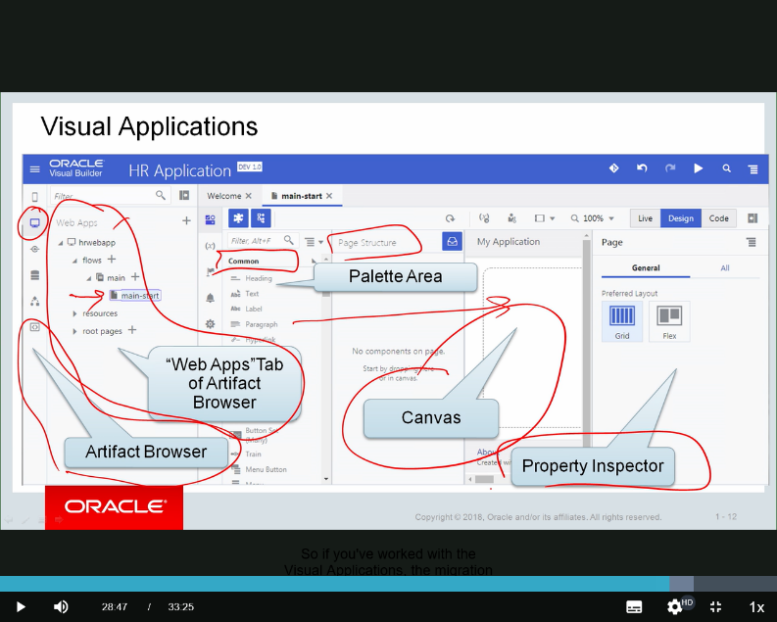So within web applications, we have different flow here down to a specific page. It's showing us that page over here on the canvas piece that we can see right here. And that would display over here.

We also have-- so this is that Web Apps section, which we see identified here. The Artifact Browser, which we saw on the previous slide.

Notice our palette area. Within here we have our different components. Here are common components and different types of components that we can then drag and drop into the canvas. So this is very similar to what we saw in the Classic View. As you start constructing your page, you have a Page Structure. And we still have the Property Inspector.

So if you've worked with the Visual Applications, the migration or the evolution or the learning curve from Visual Applications to-- from the Classic Applications, excuse me, to the Visual Applications is very simple. The terminology is very similar. Basically, you'll see within the Visual Applications, as I mentioned, it's an extension. It's a next level of flexibility from the classic apps. And you can see that here with a lot of the terminology that's very similar.

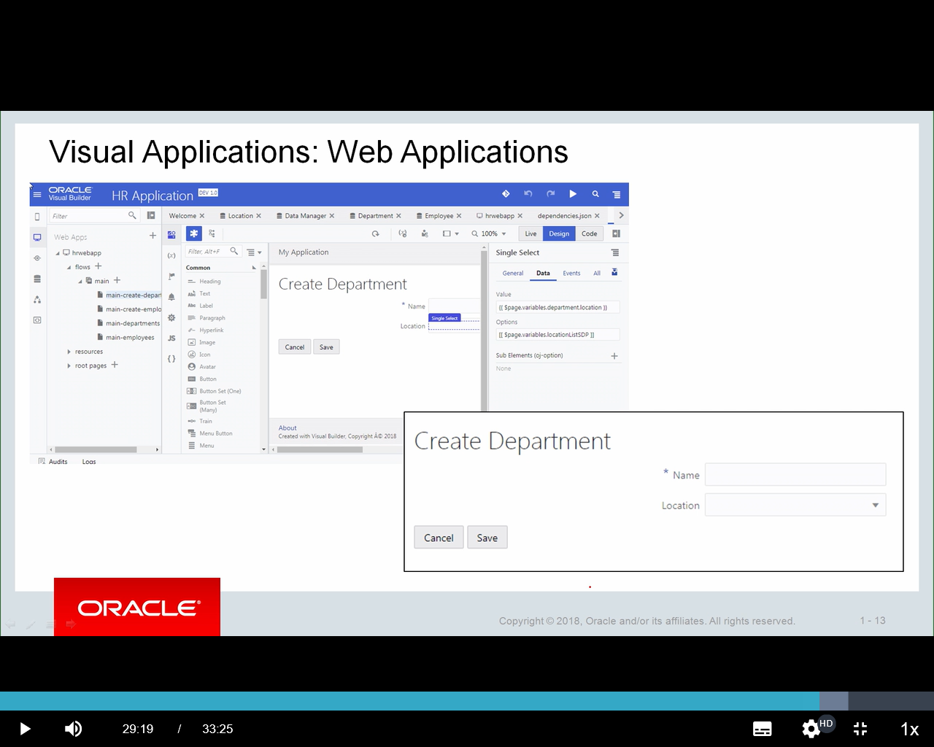When you're creating a web application, for example-- so here are those different areas that we saw in your Developer tool.

In this particular case, we're looking at the **page developer. We're building an application.**

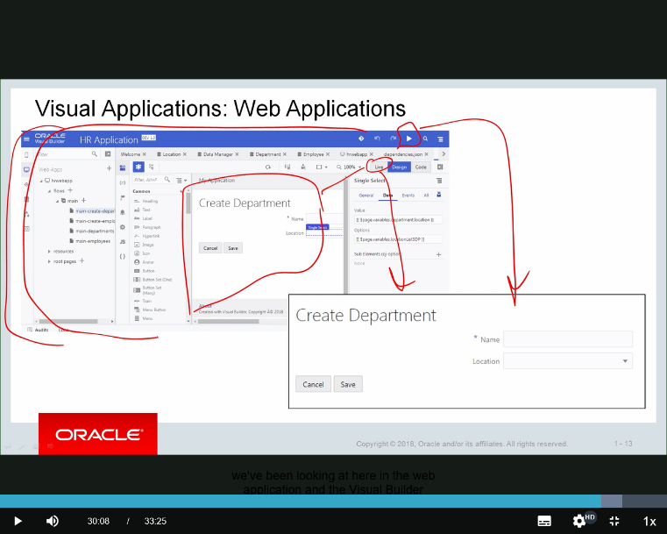And we have the ability to go test that. So we can test it a couple of different ways. But basically, here's the page development view. We can test it with a live view. We can also test it using this, which brings up a separate page. But either one of these will give us the ability to dynamically test our application as we're constructing it.

So you can see in this case a fairly simple page. This is something you'll do in your practices. But we construct it by dragging and dropping. And then we can test it. And then ultimately, when it's deployed, take all this stuff we've been looking at here in the web application and the Visual Builder version and then ultimately construct our nice clean UI from that. A lot of flexibility. Still easy to use.

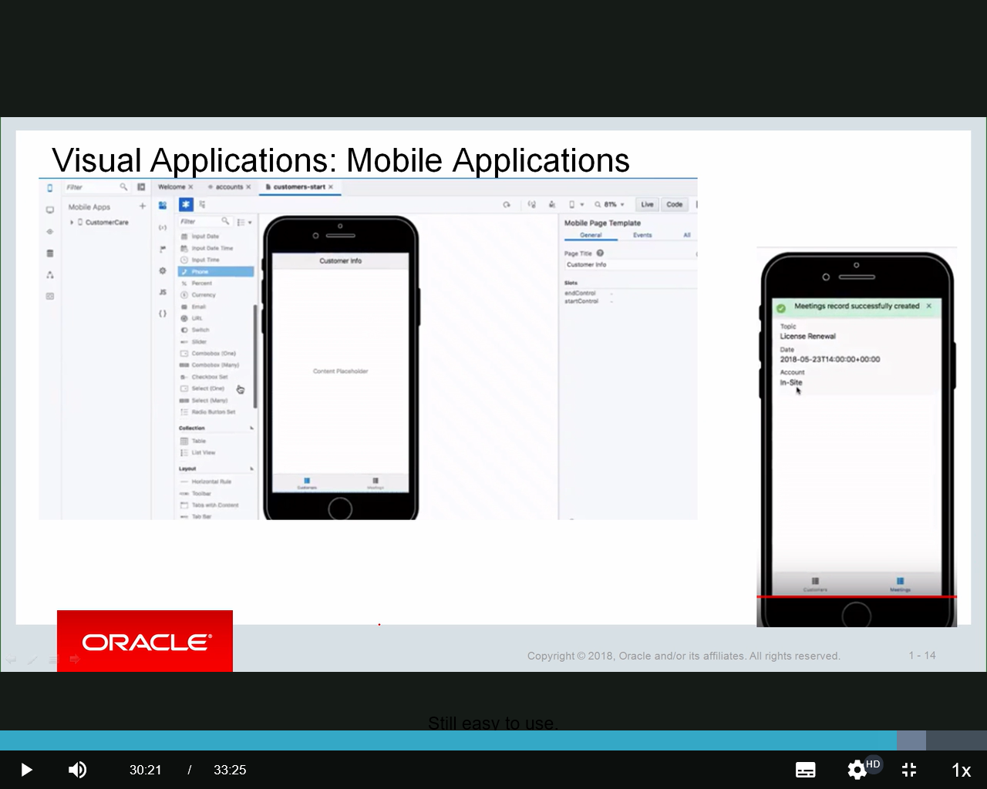

Visual Applications also has the ability for **mobile applications.**

So we set one application and create various approaches to that. And that's actually in the Artifact Browser over here, the first element there.

And it's constructed similarly. Notice the Design view. It's a little different. It looks like a mobile device. You've got limited real estate.

So some of the components are a little bit different. And you've got less space to manage those. You have the ability through a couple of different ways here to change the form factor that you're working with, whether it's a smaller mobile device or a mini tablet versus full-size tablet, that type of thing, horizontal, whether you looking at landscape or portrait view. So a couple of different tools here in the mobile view.

Now, throughout most of the modules in this course, we're going to focus on the web development side of things. But we wanted to let you know the mobile application capabilities are there and has very robust and similar approach to building the mobile applications as we have with the web applications.

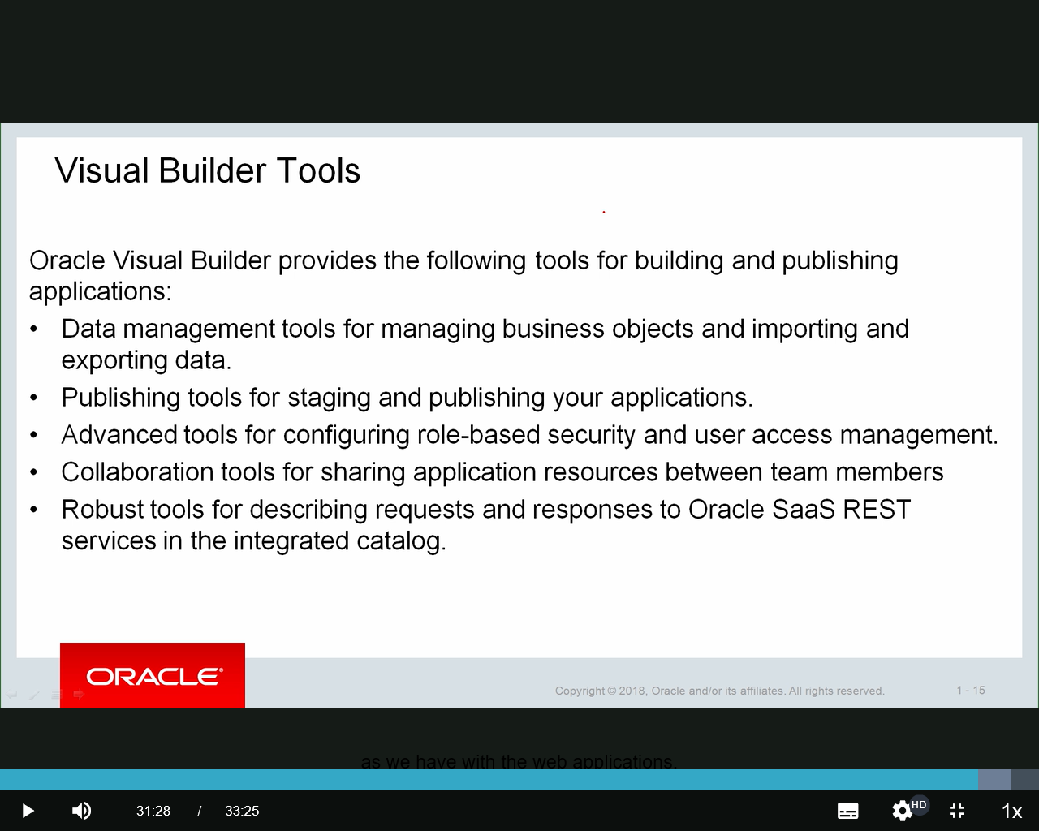All right. So that's kind of an introduction to what we're going to see a lot more of as we continue through the course and the additional modules.

So additional tools for building and publishing your applications. Some things as we go through the additional modules and lessons here is we going to see **more data management tools** for those **business objects, importing and exporting data**.

I'll give you an example of this. **You can take a spreadsheet and you can import that into Visual Builder. And it will create a custom business object for you. Then you can build your applications off of that.**

We have various publishing tools. And the **publishing tools** is basically your lifecycle management. You're in development mode. You can then stage the application for testing, share the URL with folks who you want to test it, and then ultimately publish.

And remember, it's being hosted on the cloud. You give them a URL. Say, here's the application.

You set up security for them if you want to. They can be anonymous users or they can be non-anonymous-- your application can allow anonymous users, anybody, or you can set up by user ID. And we'll see that a little later. But the tools are there for that.

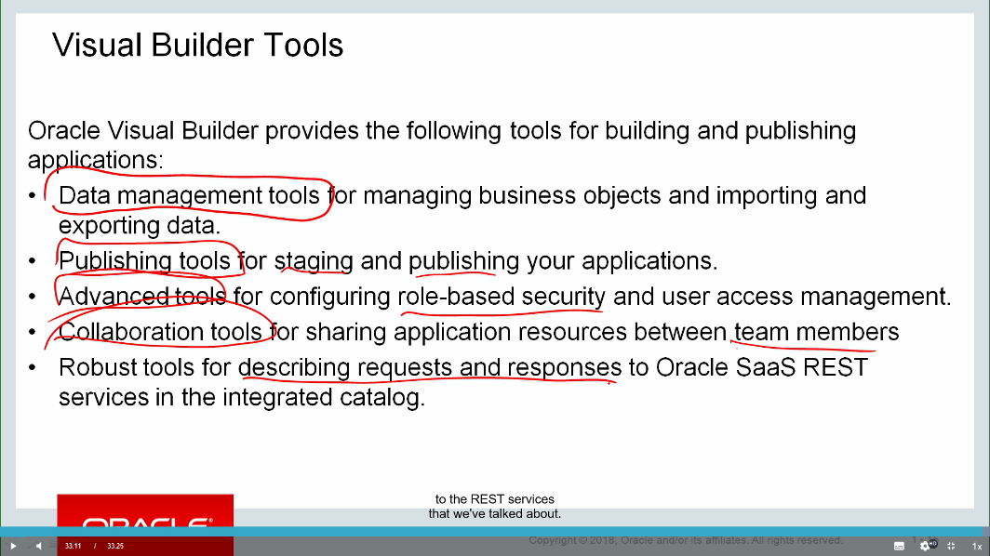There's some **advanced tools for configuring that role-based security and user access management**. So you have those capabilities built in above and beyond the cloud security that's already in place. This is specific to an application. And as we talk about this, not just the application itself, but **different levels of an application, the application in its entirety, a page, or even a business object, or even fields in a business object can be secured.**

There's **collaborative tools** for sharing applications between team members. We can set up different team members and we can share the development effort. And then there's some other tools for describing requests and responses to the REST services that we've talked about. That's the whole SaaS catalog and being able to leverage that and above that, using those REST capabilities to connect to other REST APIs that may be available.